A PROJECT REPORT ON

WonderIndia Tours Project Report

# 1. Overview

The WonderIndia Tours website is designed to provide a seamless platform for travelers to explore, plan, and book their journeys across India. It highlights the cultural richness, natural beauty, and diverse experiences of India through engaging visuals, detailed itineraries, and easy booking options. The site ensures a responsive, mobile-friendly design with smooth navigation, making it accessible to users on any device. It focuses on delivering an effortless travel planning experience that blends tradition with modern technology.

# 2. Objectives

* Enhance Travel Accessibility: Provide detailed travel information, destinations, and packages for tourists to easily explore.
* Boost Tour Bookings: Simplify booking processes with clear package details and 'Book Now' options to encourage conversions.
* Build Trust & Reliability: Highlight inclusions, itineraries, and travel details transparently to make customers feel secure.
* Improve User Experience: Create a responsive, fast-loading, and easy-to-navigate website for all users.
* Promote Indian Tourism: Showcase India's diverse culture, heritage, and natural beauty through curated travel experiences.

# 3. Key Features

* Homepage: A visually appealing page with a hero banner, navigation bar, featured services, and highlighted destinations.
* Services Page: Describes the travel services offered such as tour packages, destination guides, and customer support.
* Destinations Page: Categorized destinations (North, South, East, West India) with detailed travel highlights.
* Packages Page: Offers curated travel packages with itineraries, inclusions, prices, and discounts.
* About Us Page: Provides company background, mission, and vision to build customer trust.
* Contact Us Page: Enables users to reach the company with forms, emails, and social media links.
* Booking Pages: Individual package booking pages with itineraries, inclusions, and 'Proceed to Book' options.
* Responsive Design: Built with HTML5, CSS3, Bootstrap5, and JavaScript for a seamless experience on all devices.

# 4. Output Screens

* Home Page: Hero banner, navbar, featured services, and call-to-action buttons.
* Services Page: Detailed overview of services provided.
* Top Destinations Page: Categorized cards showcasing popular Indian destinations.
* Packages Page: Multiple travel packages with 'Book Now' buttons.
* Booking Pages: Detailed itinerary and inclusions for each selected package.
* About Us Page: Information about the purpose, mission, and team.
* Contact Us Page: Contact form, company details, and social media links.
* Footer Section: Includes logo, copyright, and social media handles.

WonderIndia Homepage

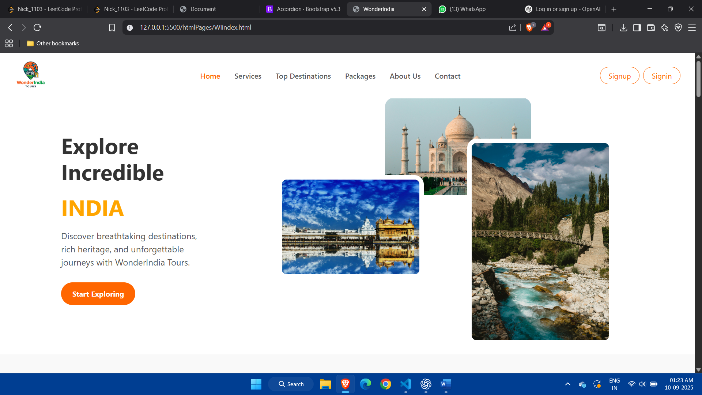

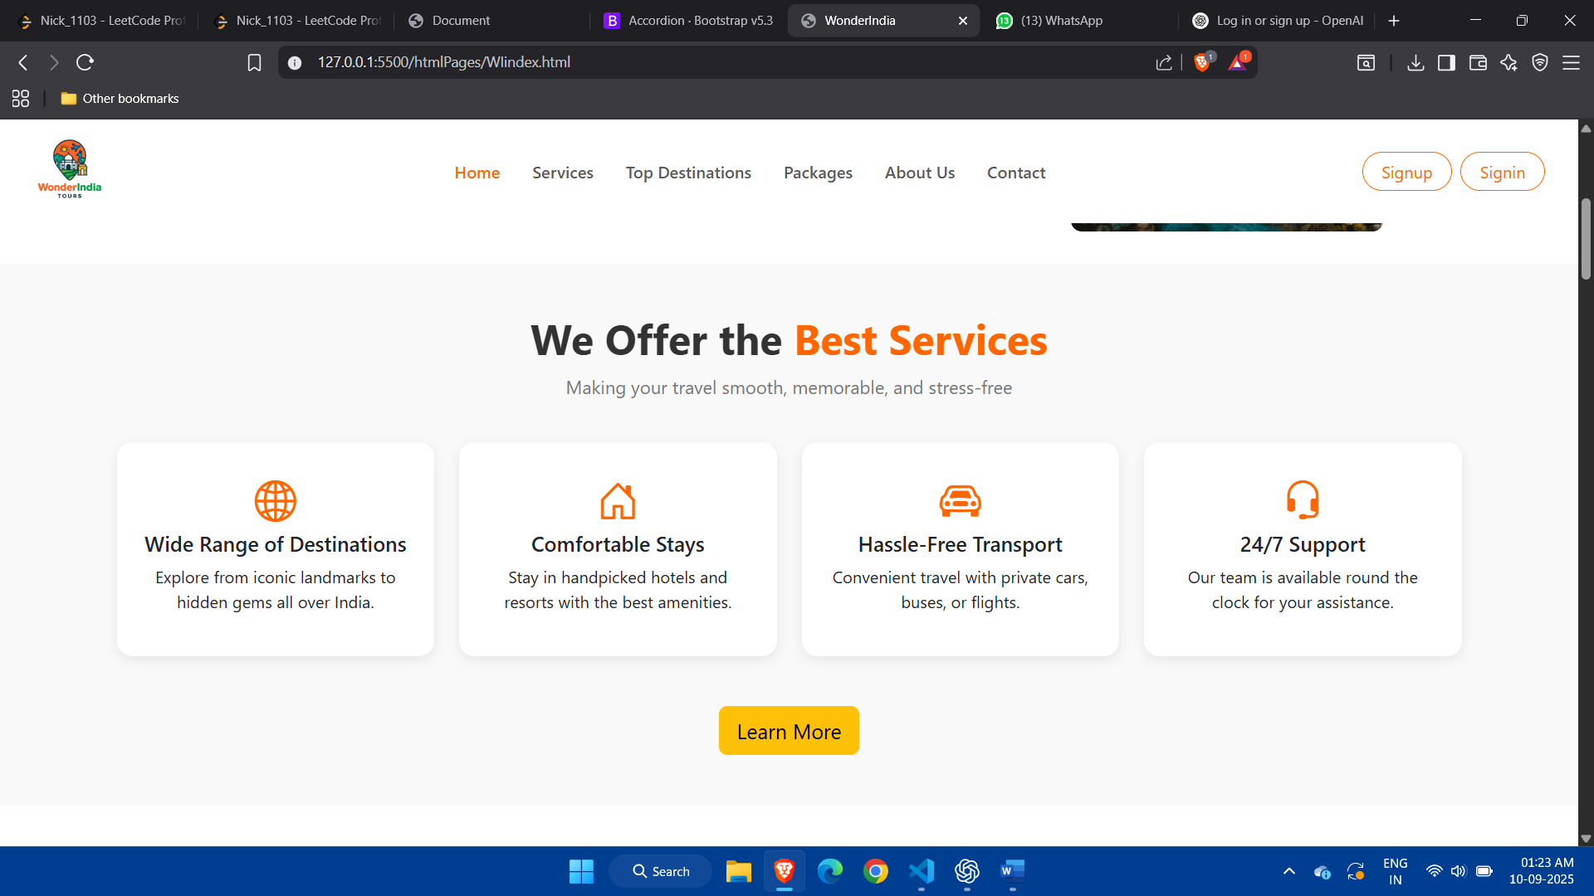

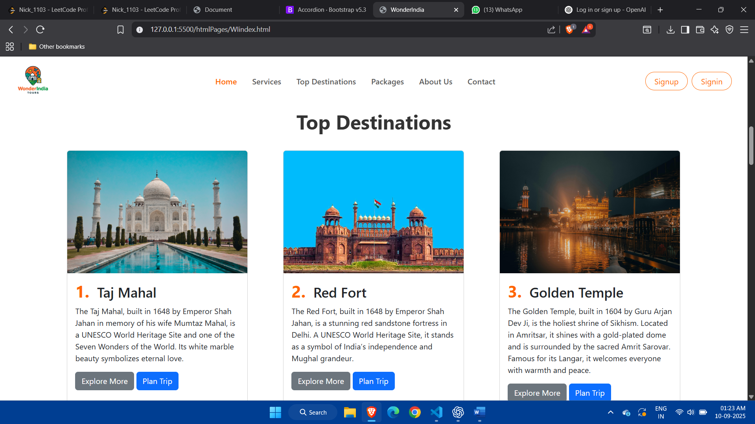

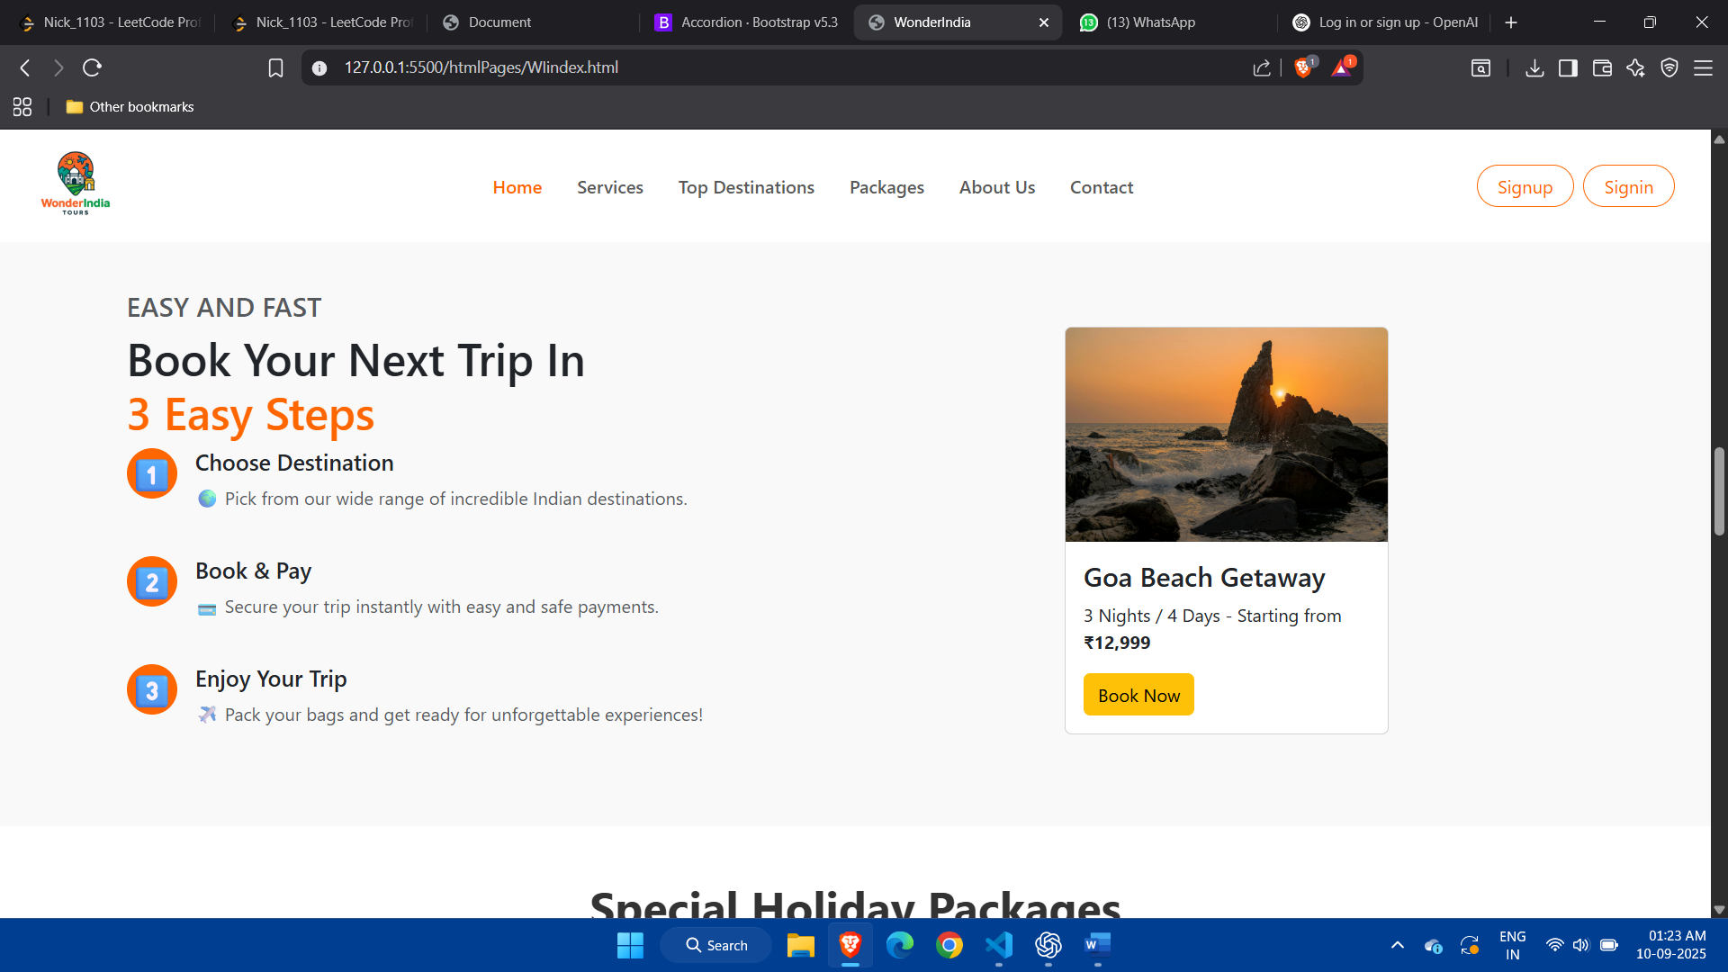

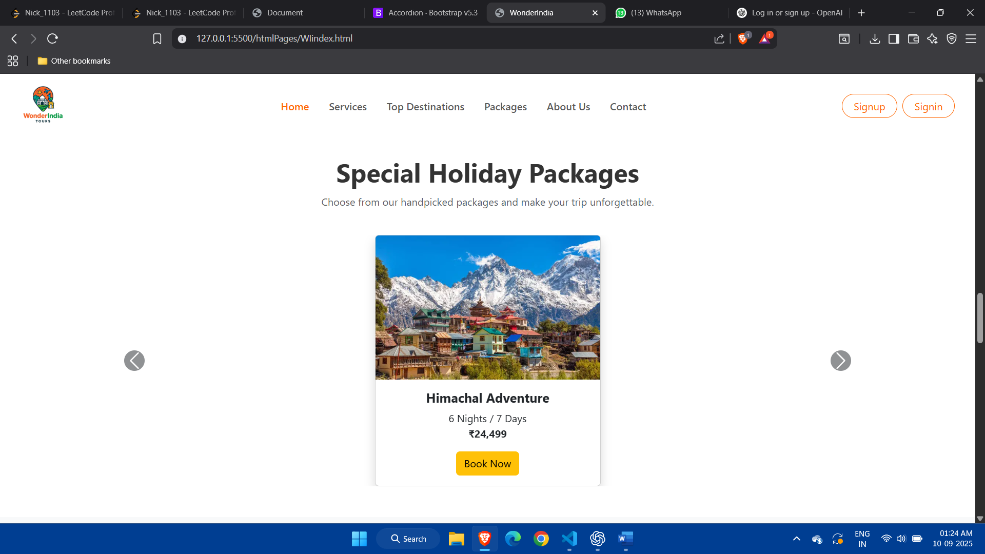

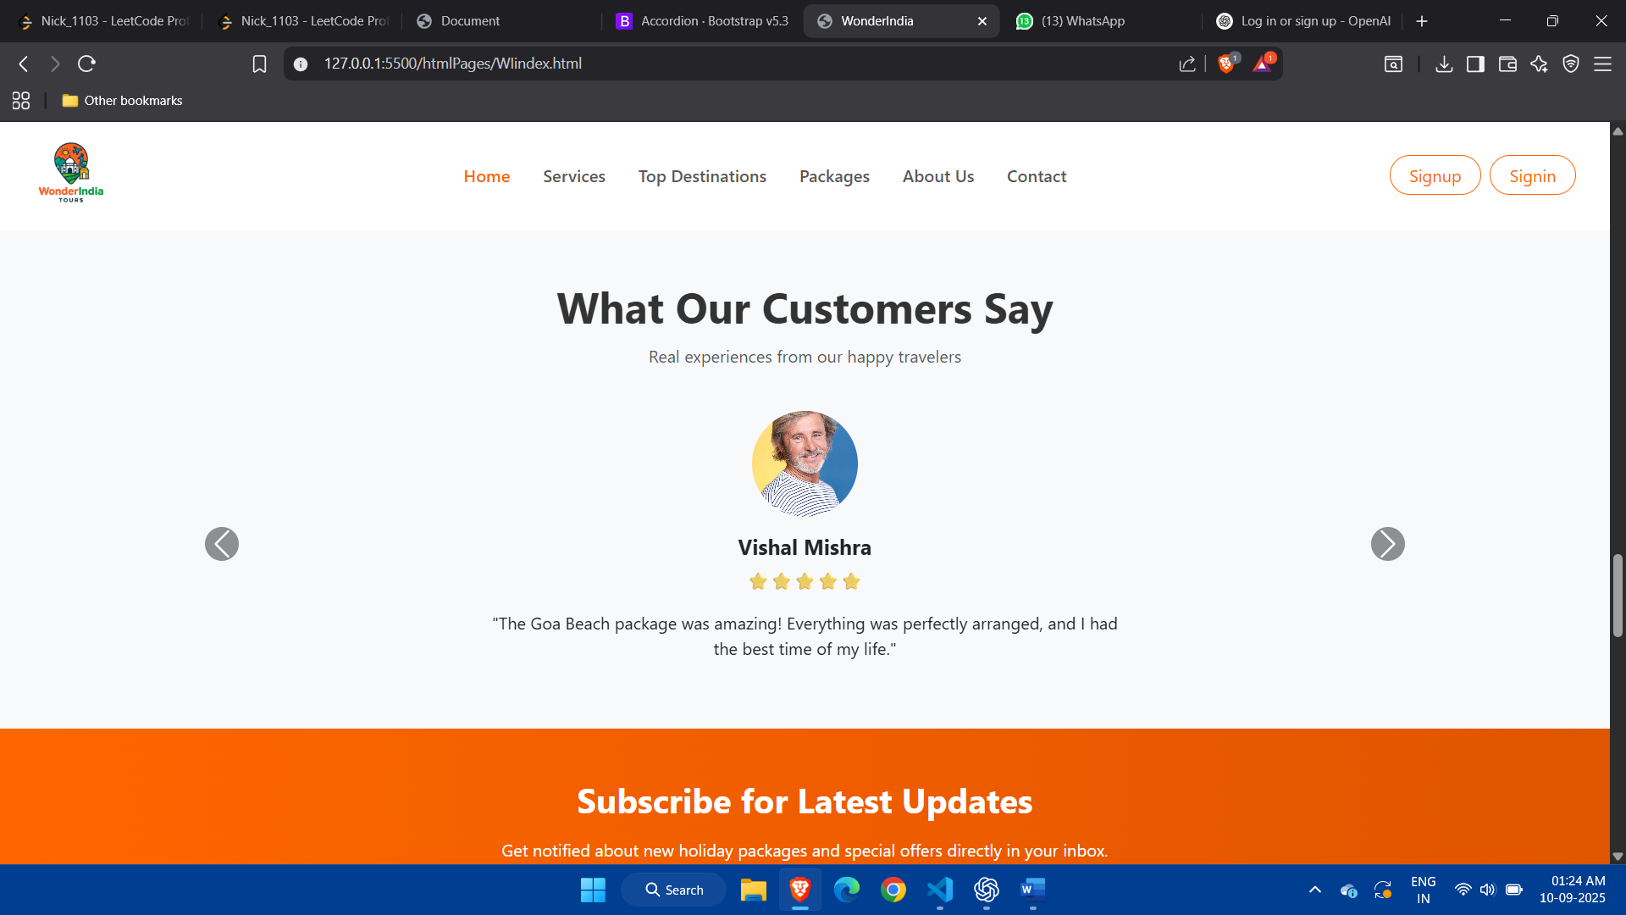

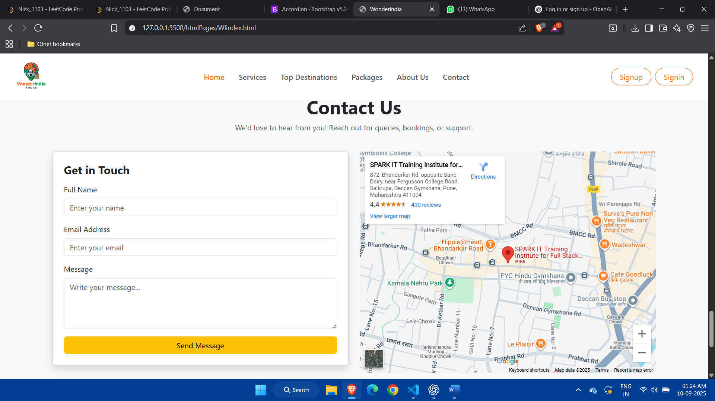

Services:

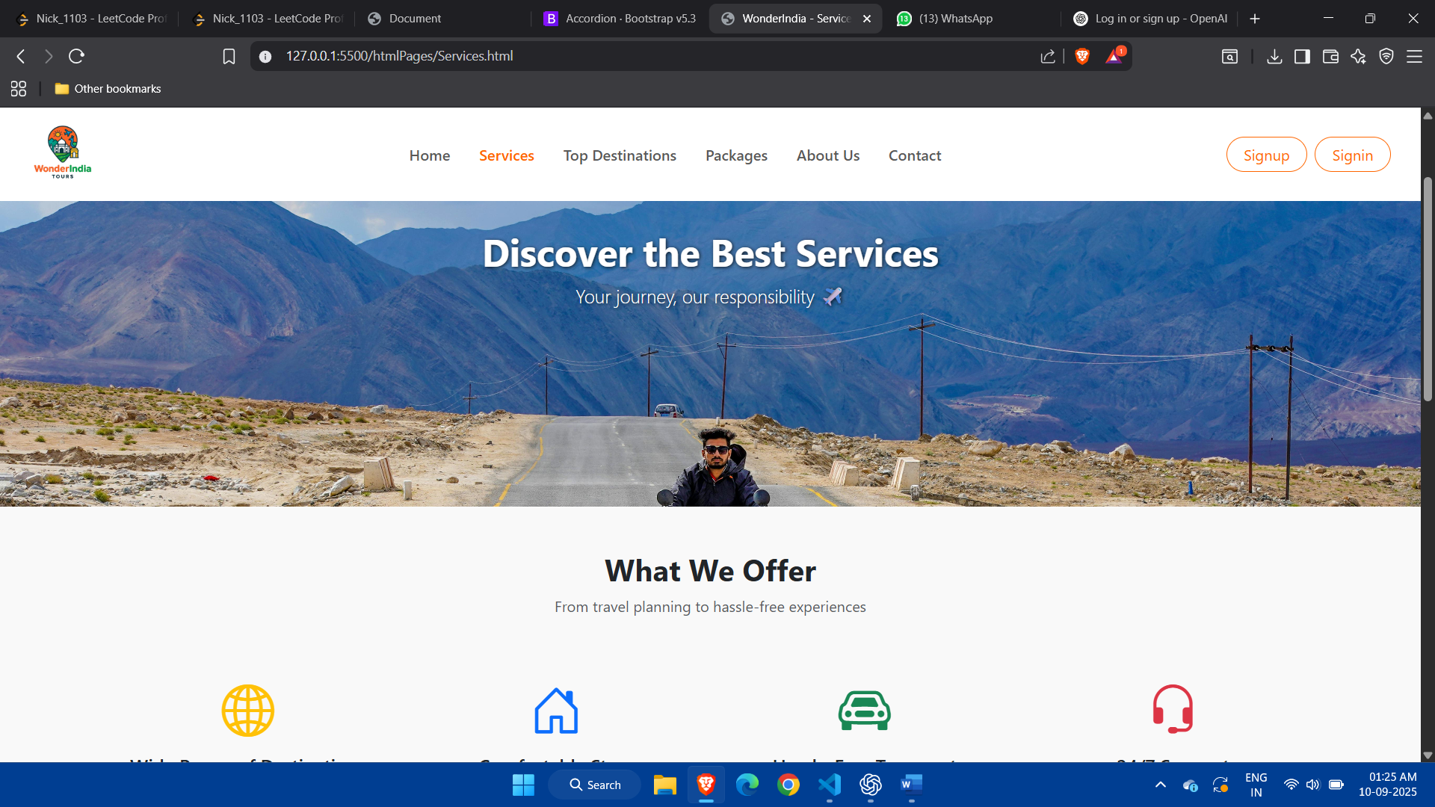

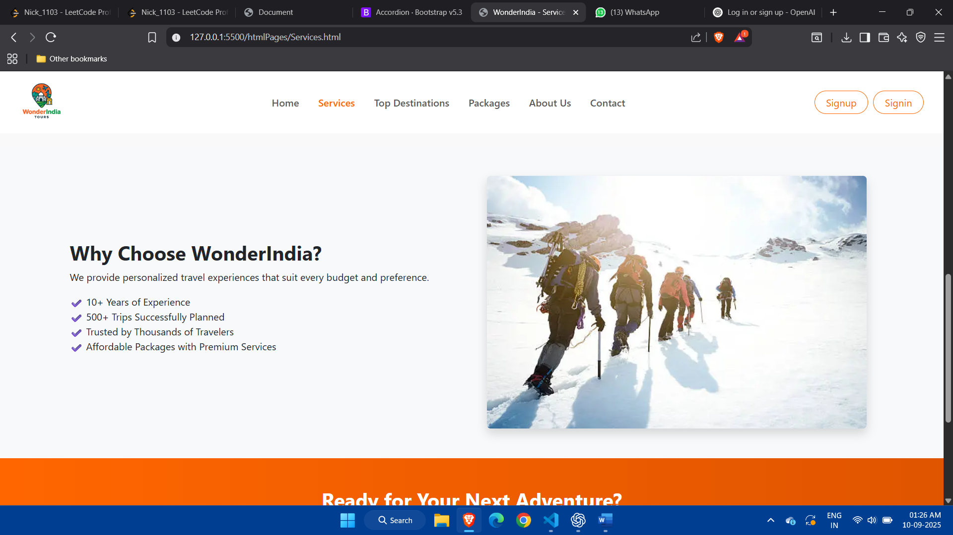

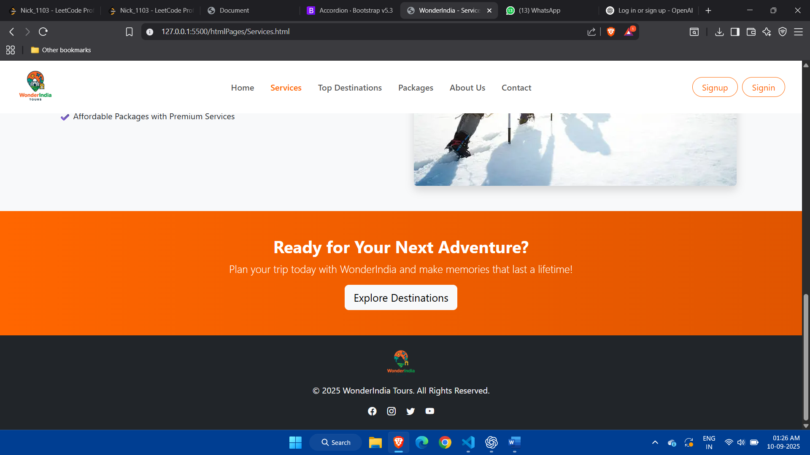

Top Destination:

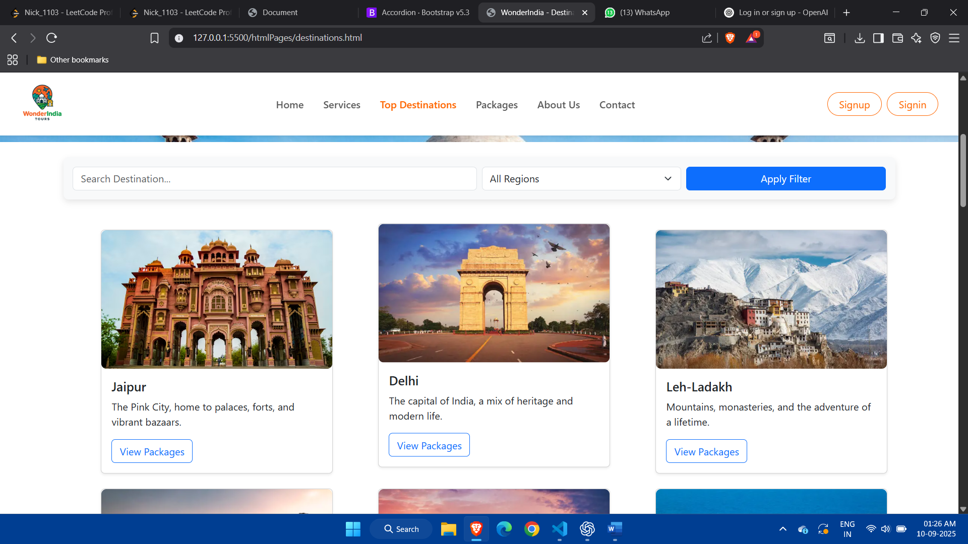

Packages:

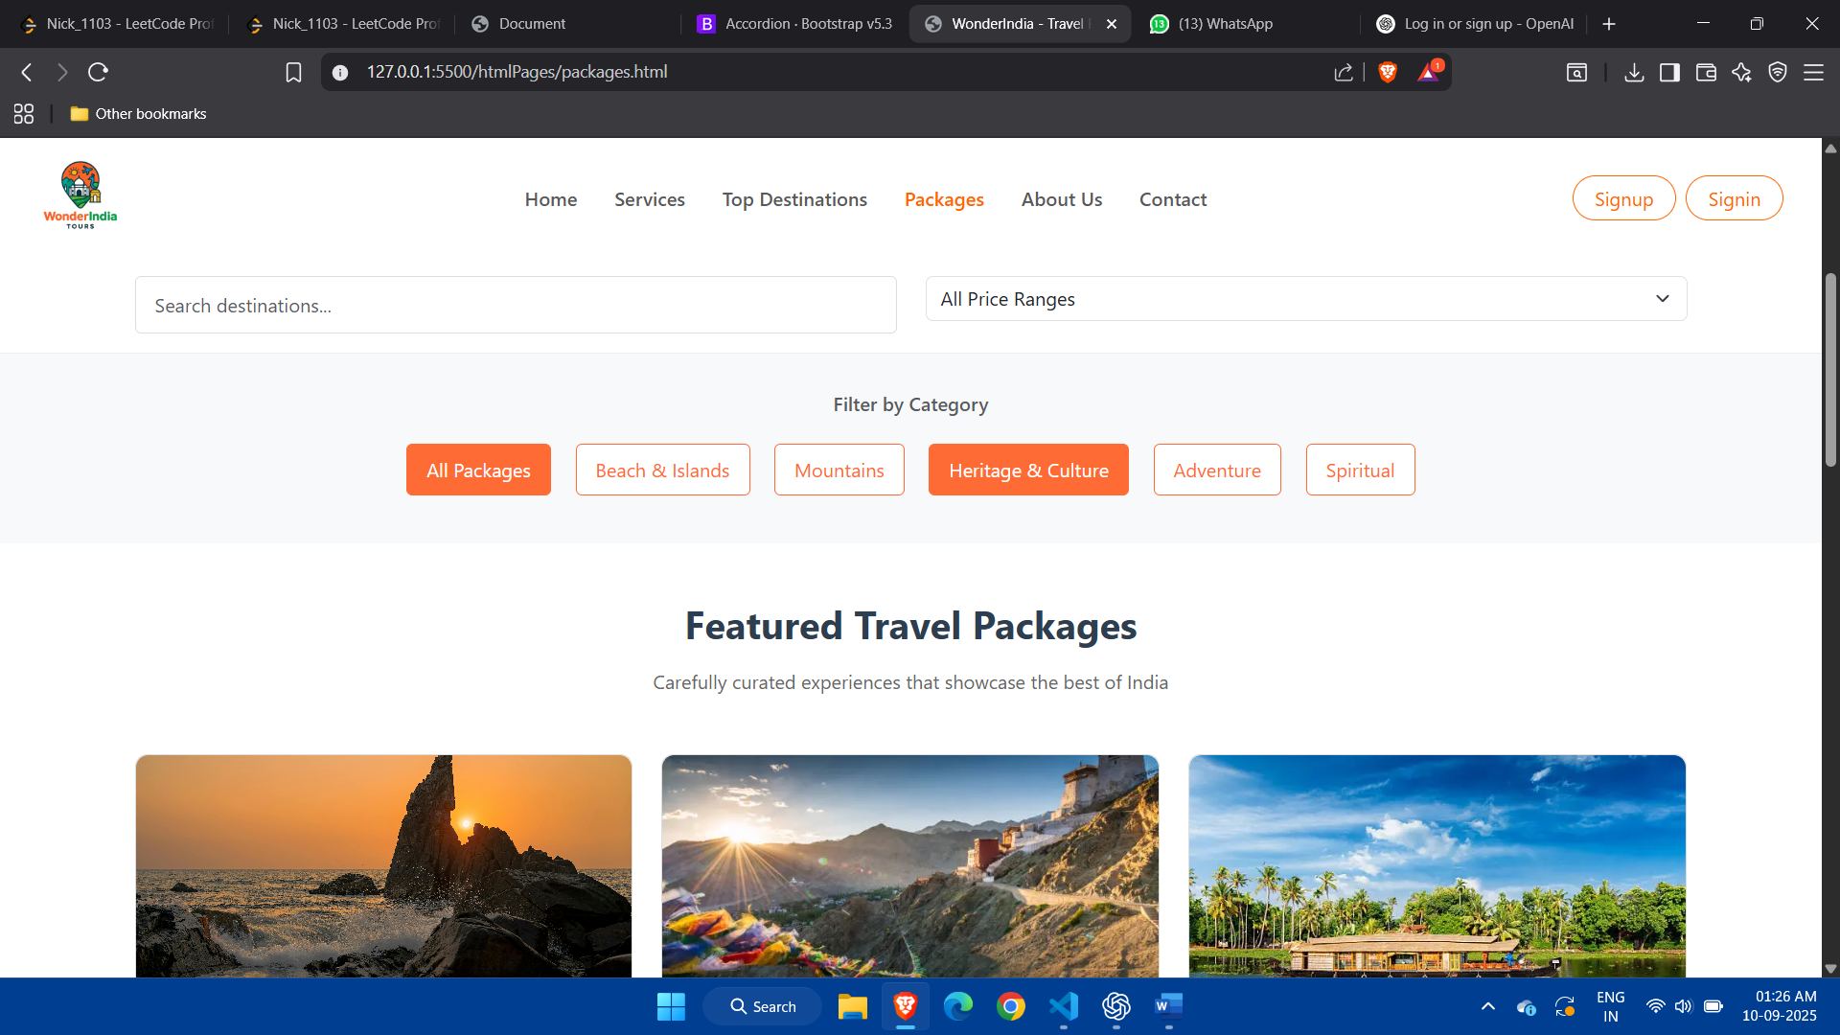

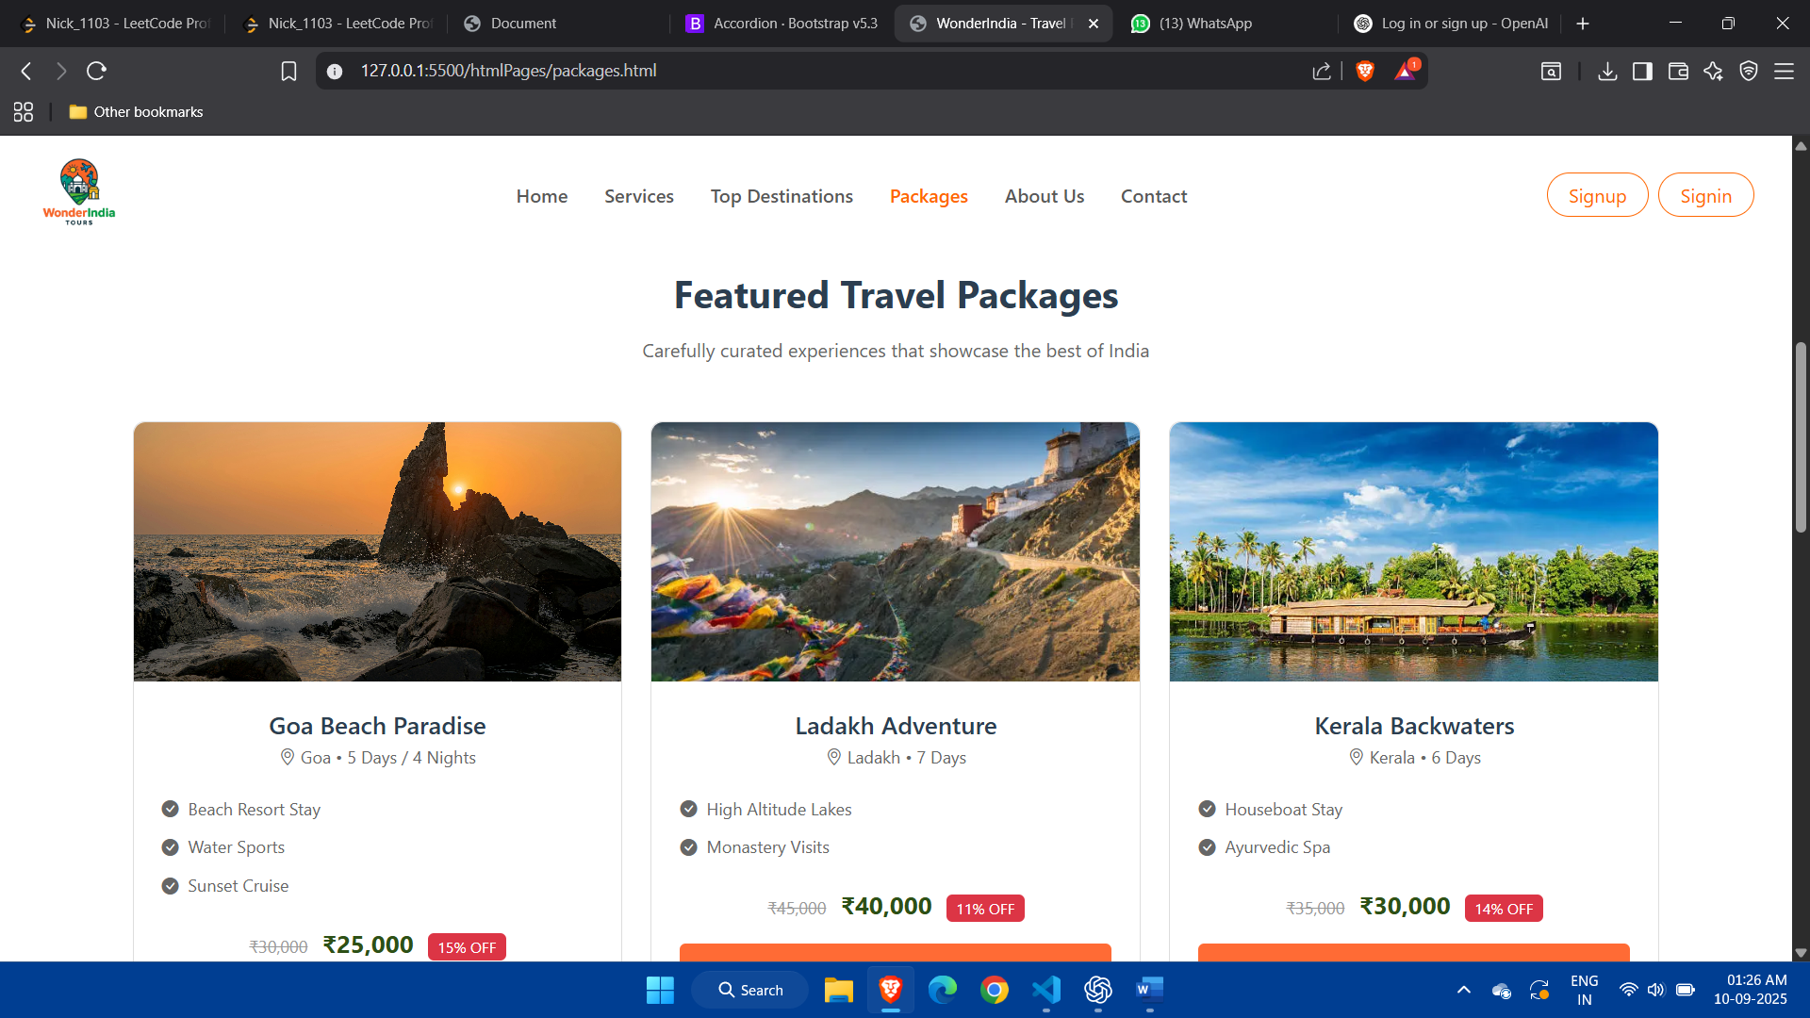

Contact Us:

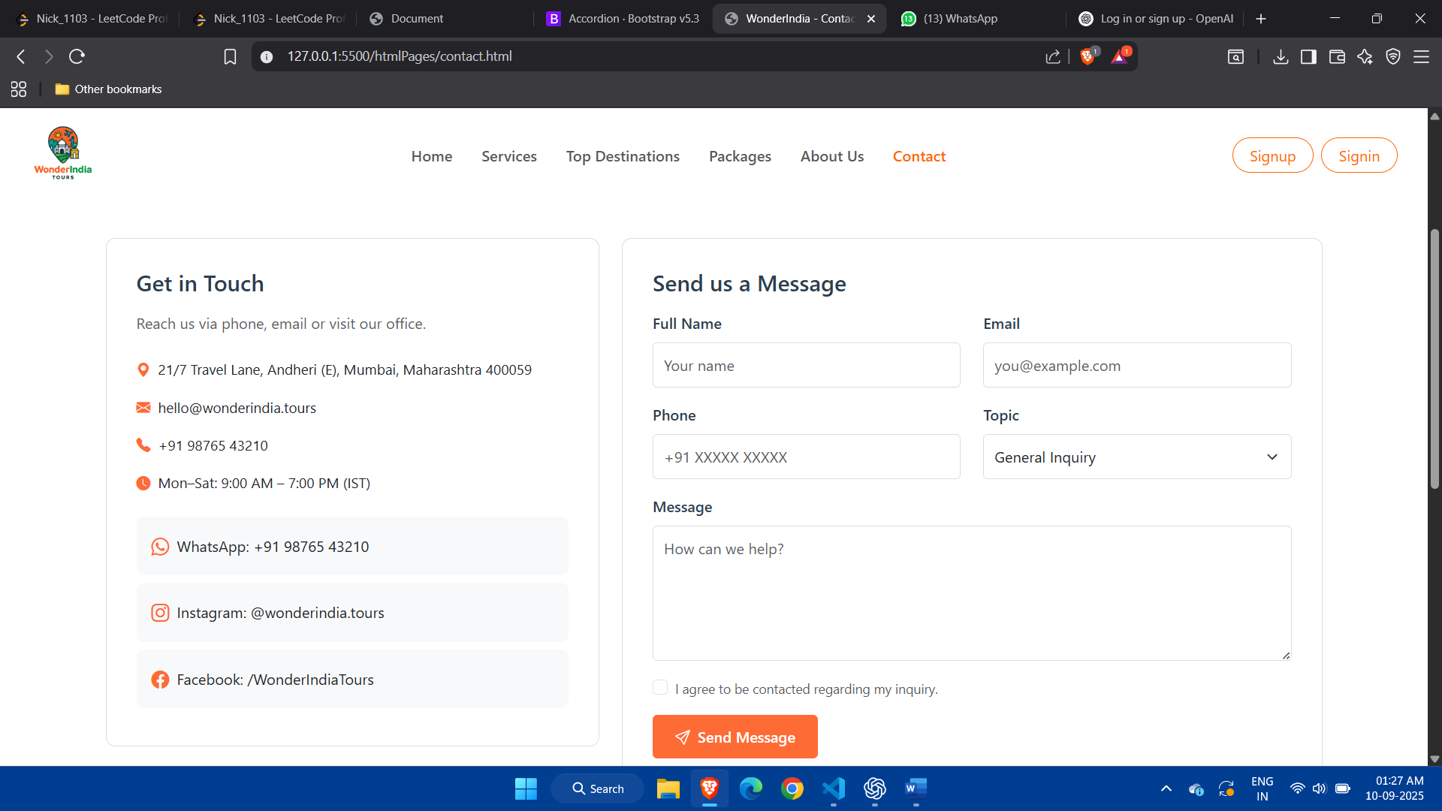

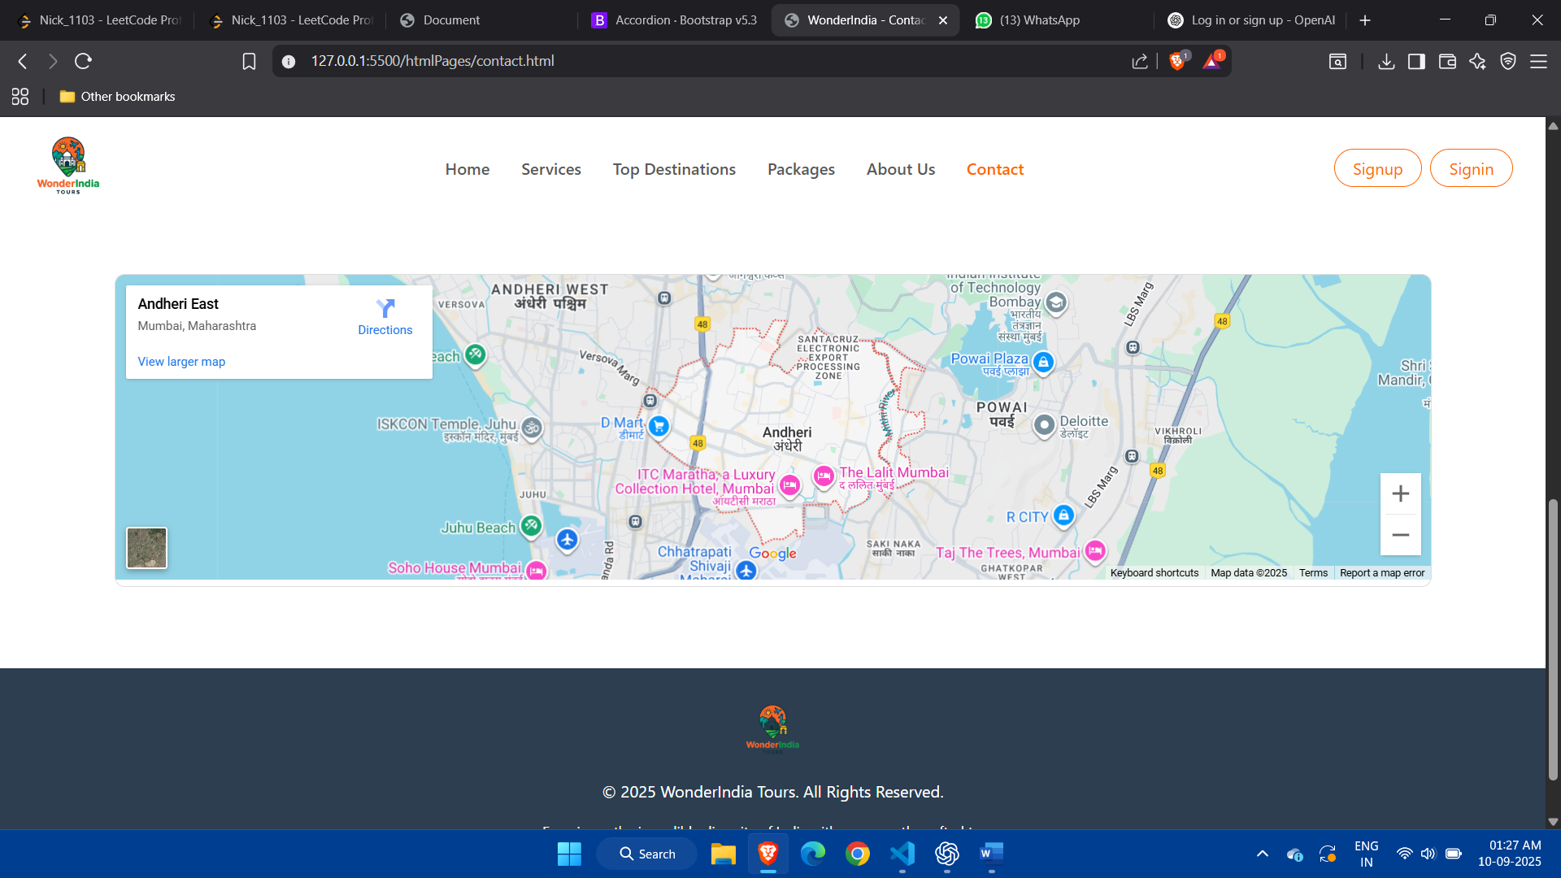

SignUp:

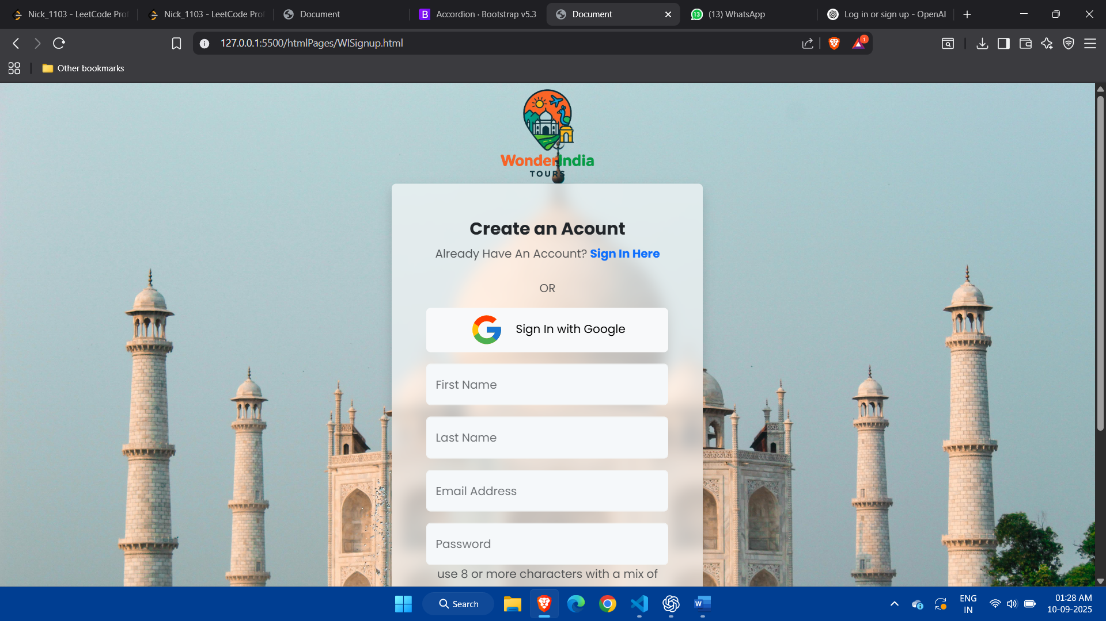

SignIn:

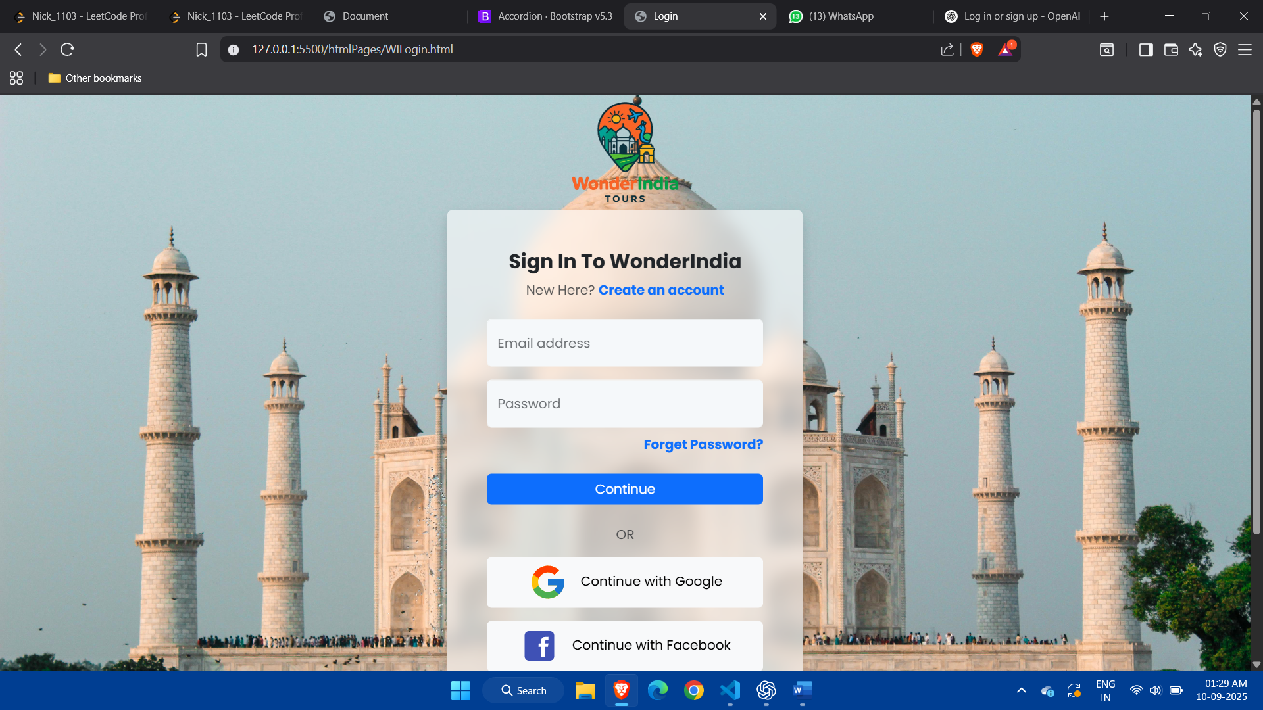

Package:

